Indlu Ephezulu

Kulusuku lokucina lukaJesu. Kusasa uzakufa. Wayehlezi ebatshela abafundi bakhe ukuthi isikhathi sakhe siyeza esokuthi umele abatshiye abesesifa – kodwa bakhanya bengakuqedisisi ukuthi wayesitshoni. Simangala ukuti kungani kuzakuba njalo.

Usuku lwakhe lokucina wayezaluchitha labafundi bakhe. Kwakungumkhosi weDlulaphezulu, isikhathi lapho amaJuda akhumbula iwundlu lihlatshwa, igazi lifafazwa emnyango, ingilosi yokufa isedlula phezu kwezindlu zabo. Iminyaka ngeminyaka bakhumbula lokhu. Khathesi isikhathi sasesifikile kanye njalo, njalo kwakulenkulungwane zabantu ezazize eJerusalema ukuzagubha umkhosi.

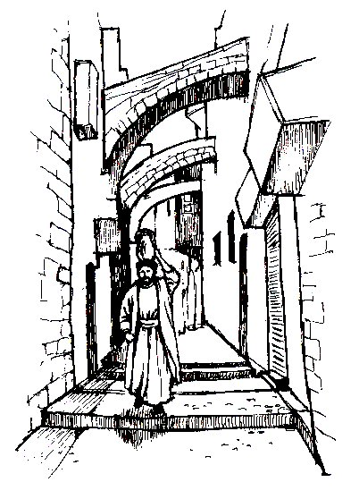
INkosi uJesu yayizagubha umkhosi labafundi bayo. Ngakho yathuma ababili kubafundi bayo ukuthi bayelungisa konke – isinkwa, iwayini, iwundlu. Kodwa kuqala baswela lapho ababengadlela khona. Ngakho wathuma ababili babo ukuthi bayedinga indawo.

Lamadoda amabili ahlezi akhangeleni nxa behamba ezitaladeni? Into engejwayelekanga – indoda ethwele imbiza yamanzi ekhanda layo. (Ngokujwayekileyo kwakungaba ngabesifazana abenza lokhu.) UJesu wayebatshele ukuthi badinge indoda le babesebeyilandela. Ekucineni bayayibona, babesebesenza njengokutshelwa kwabo.
Indoda iyangena endlini; ngakho bobabili bayayilandela lapho engene khona. “Ingaphi indawo lapho uMfundisi azagcina khona iDlulaphezulu?” babuza umnini wendlu; yena-ke ngomusa ubatshengisa indawo. Yona yindlu esitezi phezulu. Ukhanya engamangalanga. Konke kulungile uJesu wazi konke, wayekwazi-ke ukuthi lindoda izakwenzani njalo ithini.

Kulandela lokho uJesu labafundi bakhe bonke babuthana kule indlu basebeqala ukudla lokunatha. Kufanele ukuthi bathokoza kangakanani! Kodwa hatshi! UJesu wahle wathi, “Omunye wenu uzanginikela mina ezitheni zami ezizangibulala”.

Abafundi bethuka. Bakhangelana belusizi. “Yimi yini?” omunye wabuza. Lomunye laye, “Yimi yini?” UJesu wathi, “Kungulowo ozagxamuza isandla sakhe emganwini kanye lami”.

Lowo owakwenzayo lokho nguJudasi Iskariyothi. Wayengomunye wabafundi bakaJesu, kodwa wayengamthandi. Wayengumuntu omubi lanxa abanye abafundi babengakwazi lokhu. Wayelisela. Wayentshontsha. Njalo wayefuna ukususa uJesu. Wayekhulume lezitha zikaJesu, wathi nxa bemnika imali, wayezabatshengisa lapho uJesu ayekhona, ukuze bamthathe bambulale. Kuyesabeka kangakanani!

UJesu wadana kakhulukazi. “Lokho ozakwenza kwenze masinya!” watsho kuJudasi. UJudasi wasephuma etshiya uJesu engena emnyameni – kokuphela.

Ungazifunda ngalokhu kuMatewu isahluko 26 amavesi 17 kusiya ku-25; uMarko isahluko 14 amavesi 12 kusiya ku-21; uLuka isahluko 22 amavesi 7 kusiya ku-18.
Isidlo SeNkosi

Kodwa iNkosi uJesu yenzani khathesi? Uthatha isinkwa etafuleni uyasihlephuna. Utshela abafundi bakhe ukuthi njengoba isinkwa besihletshunwa, masinyane umzimba wakhe wawuzahletshunwa esiphambanweni. Kwakufanele badle isinkwa esihletshuniweyo.

Kuzakuthini-ke? UJesu wathululela iwayini enkezweni wabatshela ukuthi balinathe. Wathi njengewayini lithululiwe, masinyane igazi lakhe lizathululwa esiphambanweni. Wayebathanda kangakanani abafundi bakhe!

UJesu wasesithi, nxa umhlaba ulokhu ukhona, abalandeli bakhe kumele bahlangane badle isinkwa esihletshuniweyo banathe enkezweni. Lokhu sikubiza ngokuthi yiSidlo seNkosi. UJesu wathi, “Lokhu kwenzeni ukungikhumbula”. Kabafanelanga bakhohlwe lanini ukuthi uJesu wabathanda kangakanani lapho ebafela.

Emva kwalokhu bonke bahlabela ingoma baphuma.

UJesu wasebatshela into eyesabekayo. Bonke babezamtshiya! Liyamkhumbula uPetro yini? UPetro wahlupheka kangangokuthi wathi nxa bonke bengayitshiya iNkosi loMfundisi wakhe ethandekayo, yena wayengeke akwenze lokhu.

Kodwa uJesu waphendula wathi: “Iqhude lingakakhali kusasa, Petro, ngabona lobubusuku, uzakuthi kawuzanga ungazi mina.”

UPetro olusizi(oyangekileyo) wakhumbula ukuthi lokhu kungezake kwenzakale. Ukuthini? Ngiphike uJesu? Ngitsho. Kodwa wakwenza!

Ungazifundela ngalokhu kuMatewu isahluko 26 amavesi 26 kusiya ku-32; uMarko isahluko 14 amavesi 22 kusiya ku-26; uLuka isahluko 22 amavesi 19 lo-20.
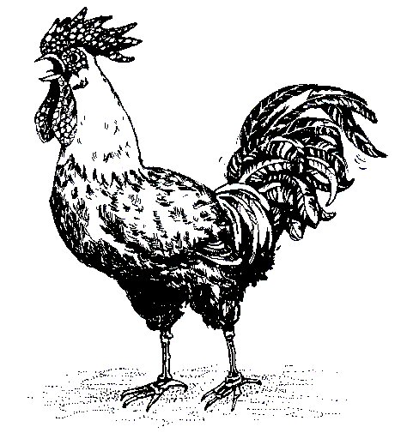
Esivandeni seGetsemane

UJesu khathesi wayesesendleni yakhe yokuyakufa. Wakwazi ukuthi abantu ababi bazambamba bambulale. Kodwa wayengesabi.

Kwakulesivande ngaphandle kwemithangala yeJerusalema. Kwakuseduze lentaba yeMihlwathi. Sasithiwa yiSivande seGetsemane. Sasiyisivande sezihlahla zemihlwathi. Yayiyindawo uJesu owayethanda ukuya kuyo ahlangane labangane bakhe akhulume labo.

Lapho uJesu wathatha uPetro loJakoba(e) loJohana(e)wabasusa kwabanye abafundi. Kodwa-ke waseqhubeka ibangana ebatshela esithi: “Manini lapha lilinde lami”.

INkosi uJesu yadabuka kakhulukazi. Isisindo esinzima sacindezela phezu kwakhe. Wakwazi ukuthi umele afe, kodwa kwakungayisikho lokhu kuphela. Wakwazi ukuthi kuzakuba yikufa okwesabekayo, hatshi ngenxa yakhe, kodwa ngenxa yabanye - ethwala sonke isisindo esesabekayo sezono zabantu bakhe. Kungesikuthi kuphela bonke abangane bakhe bazamtshiya, kodwa uYise wakhe othandekayo ezulwini wayezamfulathela.

Kwakuyinkezo ebaba kakhulukazi okwakumele ayinathe. “O Baba”, wakhuleka, “uba kusenzeka, kayikudlule kimi linkezo”, kodwa-ke wathi, “loba kunjalo intando yakho kayenziwe”. Kwakukukhulu kangaka ukububula lobuhlungu bakhe kwaze kwathi amathonsi amakhulu egazi athululekela emhlabathini evela kuye. Kathathu wabuyela kubafundi bakhe. Kathathu wabafica belele. Ungakukholwa yini lokhu? Babejunywe yibuthongo. Kathathu wakhuleka umkhuleko ofananayo. Kwasekusithi ingilosi engcwele yehla ivela ezulwini ukuzamnika amandla. Lanxa wayenguNkulunkulu sibili olamandla wonke, njalo wayengumuntu sibili wayekuswele ukuqiniswa.

Ekucineni wamemeza kubafundi bakhe wathi: “Lalani-ke liphumule. Isikhathi sesifikile. Khathesi sengizanikelwa. Sukumani. Kasihambe.”

Uthando olungakanani iNkosi uJesu eyalutshengisayo!

Ungafunda ngalokhu kuMatewu isahluko 26 amavesi 36 kusiya ku-42; uMarko isahluko 14, amavesi 32 kusiya ku-42; uLuka isahluko 22, amavesi 39 kusiya ku-46.

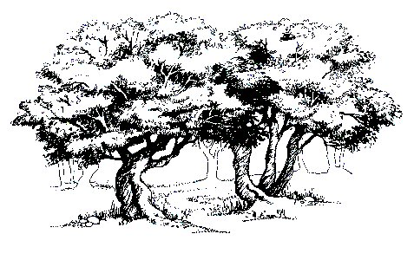
Ukubotshwa

Ziyini-ke zonke lezizibane? Njalo ngobani bonke lababantu abahaluzelayo besiza bedabula ebunyameni? Bahlomile. Abanye bathwele imihedla. Abanye imikhonto. Abanye induku. Abanye bangamasotsha. Abanye ngabapristi.

Ngubani-ke lowo ophambili? Ngumnikeli uJudasi Iskariyothi. Utshengisa izitha zikaJesu lapho abangamthola khona. Njalo-ke wenza into embi eyesabekayo! Uyamanga uJesu. Ubatshelile ukuthi lowo azamanga nguye kumele bambambe. “Judasi”, kutshi iNkosi uJesu, “uyanginikela yini ngokwanga?”

Ixuku liyasondela phambili. Kodwa uJesu kabaleki. Uyahamba ukubahlangabeza. Uyababuza: “Lidinga bani?”

“UJesu weNazaretha”, bayamemeza.

“Nginguye”, iNkosi uJesu ibaphendula ipholile. Unakana ukuthi kwenzakalani? Ekuzwakaleni kwelizwi lakhe elilamandla amakhulu, bonke bawa nyovane emhlabathini, bengelamandla.

UJesu wabatshengisa amandla alawo ngoba enguNkulunkulu olamandla wonke. Lanxa wayezakufa wayefanele abafundise ukuthi kwakungasikuthi kalamandla. Kwakufanele abatshengise ukuthi ungubani. Katshongo yini ukuthi: “Kakulamuntu ongangithathela impilo yami. Ngilamandla okuyibeka phansi; njalo ngilamandla okubuye ngiyithathe”?

Sibuye sikhumbule ngothando olumangalisayo lukaJesu. Kulula kangakanani kuye ukuphepha!

Uyalazi yini lelivesi?

“Kwakuyi ngxenye elula
Kuye ukubalekela isiphambano,
Kodwa uthando ezonini lugcwalisa inhliziyo yakhe,
Luwamenza-ke akhethe ukufa.”

Ungakhumbula ukuthi khathesi ngabe bonke sebethukile babaleka ngenxa yokwesaba. Kodwa hatshi! Babuye beza. UJesu-ke wabuye wababuza wathi: “Limdinga bani?” Babuye bathi: “UJesu weNazaretha.” Kodwa khathesi wazinikela ezandleni zabo ezimbi ezilesihluku. Wathi: “Ngithathani, kodwa yekelani laba abalandeli bami bazihambele.”

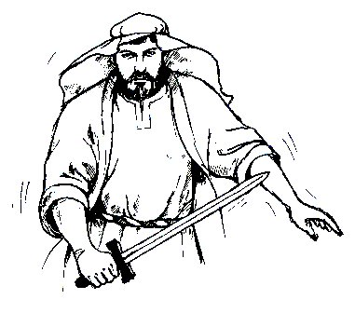
Kakumangalisi, angitsho, uPetro wayezonde kangaka ukuthi wahwatsha umhedla wakhe wabahlasela, waze waquma indlebe yomunye wamadoda. Kodwa hatshi! UJesu wathi: “Buyisela umhedla wakho Petro. UBaba unginike inkezo ebabayo ukuthi ngiyinathe njalo ngizayinatha”. UJesu wasesenza indlebe yendoda yaba ngcono. Yikuba lomusa kwakhe okungaka! UJesu wayengaswele muntu ukuthi amlwele ngomhedla. Ngabe wacela inkulungwane zezingilosi zazingeza zivela ezulwini ukuthi zimlwele.

Wasevumela amasotsha ukuthi ambophe amthathe ahambele laye.

Ungafunda ngalokhu kuMatewu isahluko 26 amavesi 47 kusiya ku-56; uMarko isahluko 14 amavesi 43 kusiya ku-52; uLuka isahluko 22 amavesi 47 kusiya ku-53; uJohane isahluko 18 amavesi 1 kusiya ku-12.

“Wayengekho olunge okwaneleyo
Ukubhadala intengo yesono;
Yena kuphela wayengavula isango
Lamazulu ukuthi asingenise.”

UJesu Uphambi KukaMpristi Omkhulu

Kuphakathi laphakathi kobusuku. Wonke umuzi weJerusalema ulele lapho lamadoda akhohlakeleyo ehaluzelisa uJesu ezitaladeni. Aya esigodlweni sikaKayafasi. UKayafasi wayengumpristi omkhulu, kodwa wayeyindoda embi. Wayengamthandi uJesu.

Babemphathelani uJesu ngaloluhlobo? Wayenzeni okubi? Wayengenzanga lutho. Kuphela wayelomusa enze okulungileyo. Kodwa abapristi lababusi kabazange bamthande ngoba wabatshela ngendlela zabo ezimbi.

Esigodlweni sompristi omkhulu abantu abehlukeneyo babekhuluma izinto ezehlukeneyo ngoJesu – kodwa zonke zingavumelani. Ekucineni bathola amadoda amabi amabili ayekhulume udaba olufananayo kodwa olwalungasilo iqiniso.

Kodwa uKayafasi umpristi okhohlakeleyo waba lecebo. Wabuza: “UyiNdodana kaNkulunkulu yini?” Kwasekusithi uJesu esethe, yebo, wasesithi yena ufanele afe. Kodwa kungani? UJesu uyiNdodana kaNkulunkulu.

Kodwa kwenzakalani-ke khathesi? Izinto ezesabekayo. Abanye bayamkhafulela ngamathe uJesu, abanye bayamhleka, abanye bayamtshaya.

Ngaphansi-ke egumeni kwakuloPetro. Wayebuyile ukuthi azebona okuzakwenzakala. Liyamkhumbula uPetro yini? Lalokho ayekutshilo? Wayengeyiphike iNkosi loMfundisi wakhe.

Kodwa khangela ukuthi kwenzakalani khathesi. Intombazana ithi: “Ungumlandeli kaJesu”. UPetro uyethuka esabe. Bangamthumba laye. “Hatshi”, wamemeza, “kangisuye”.

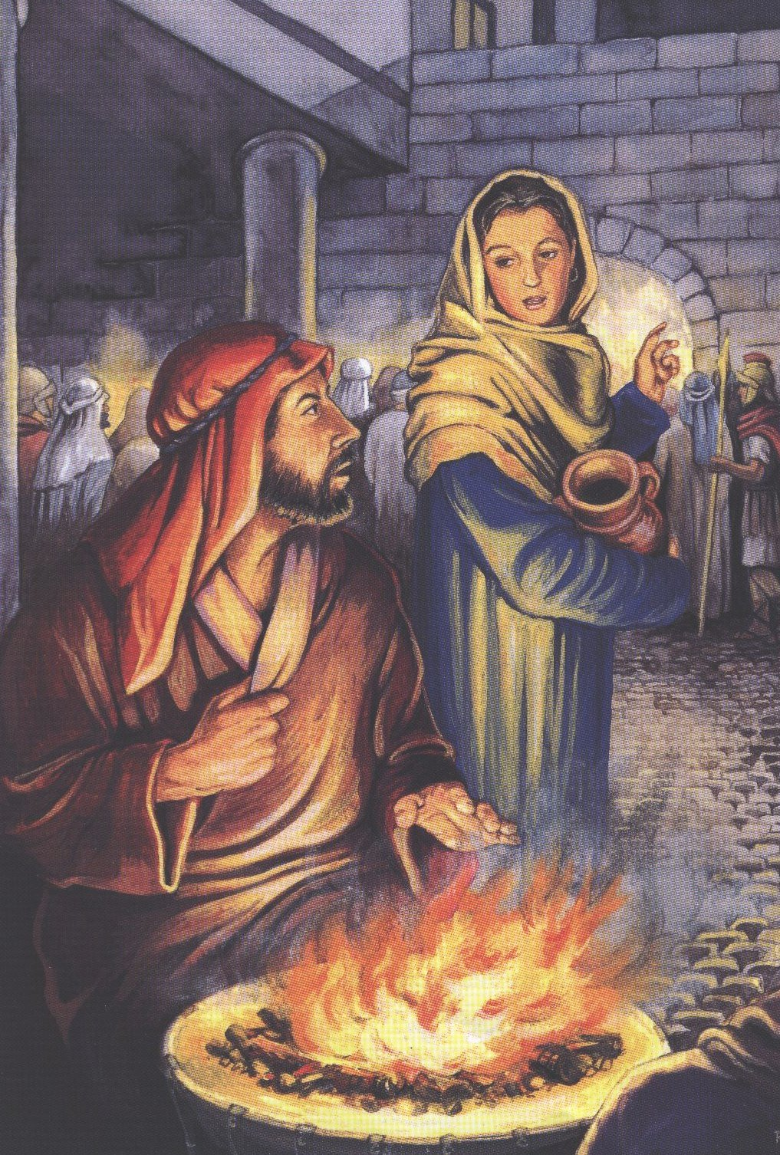
Egodola uPetro uyakotha umlilo. Enye intombazana iyambuza ukuthi angaba ngumngane kaJesu yini? UPetro ubuye athi: “Hatshi” - abesehaluzela aye endaweni emnyama lapho angeke abonakele khona.

Kodwa abantu abambalwa baleqiniso ukuthi ongomunye wabafundi bakaJesu, futhi batsho njalo. UPetro abesezonda kakhulu aqalise ukuthuka ebatshela ukuthi kazange amazi uJesu.

Ukhumbula ukuthi kwenzakalani? Ngumsindo bani lowo? Liqhude elikhalayo. UPetro wasekhumbula lokho uJesu ayemtshele khona. Wakhangela lapho uJesu ayephethwe khona ngesihluku – loJesu laye wayemkhangele. Ukumkhangela okulosizi okungakanani!

UPetro olusizana waba lenhloni ngokwenzayo. Wayenzeni? Wagijima waphuma wayakhala inyembezi. Wadabuka okubuhlungu.

Kodwa yeka lokhokukhangela! Kwamcala uPetro. Kodwa kakuyikukhangela kothando. UJesu wayelokhu emthanda, wamthethelela lanxa wayenze into eyesabeka kangaka.

Ungafunda ngalokhu kuMatewu isahluko 26 amavesi 57 kusiya ku-75; uMarko isahluko 14 amavesi 53 kusiya ku-72; uLuka isahluko 22 amavesi 54 kusiya ku-62; uJohane isahluko 18 amavesi 13 kusiya ku-27.

“Khangelani Lindoda!”

Masinyane ekuseni kwakulomhlangano omfitshane – owokuthi kubulawe uJesu. Babuya-ke bamklolodela, bamkhafulela bamtshaya. Njalo uJesu wabuye wabatshela ukuthi ungubani – iNdodana kaNkulunkulu.

UJesu sebemthatha bemusa kumbusi wamaRoma uPilatu. Kungani? Ngoba abapristi lababusi bamaJuda babengavunyelwa ukumbulala, kuphela amaRoma.

Kwakuyisigodlo esihle kakhulu lapho uJesu abamhaluzelisa khona bedabula izitalada eziminyeneyo ekuseni kakhulu.

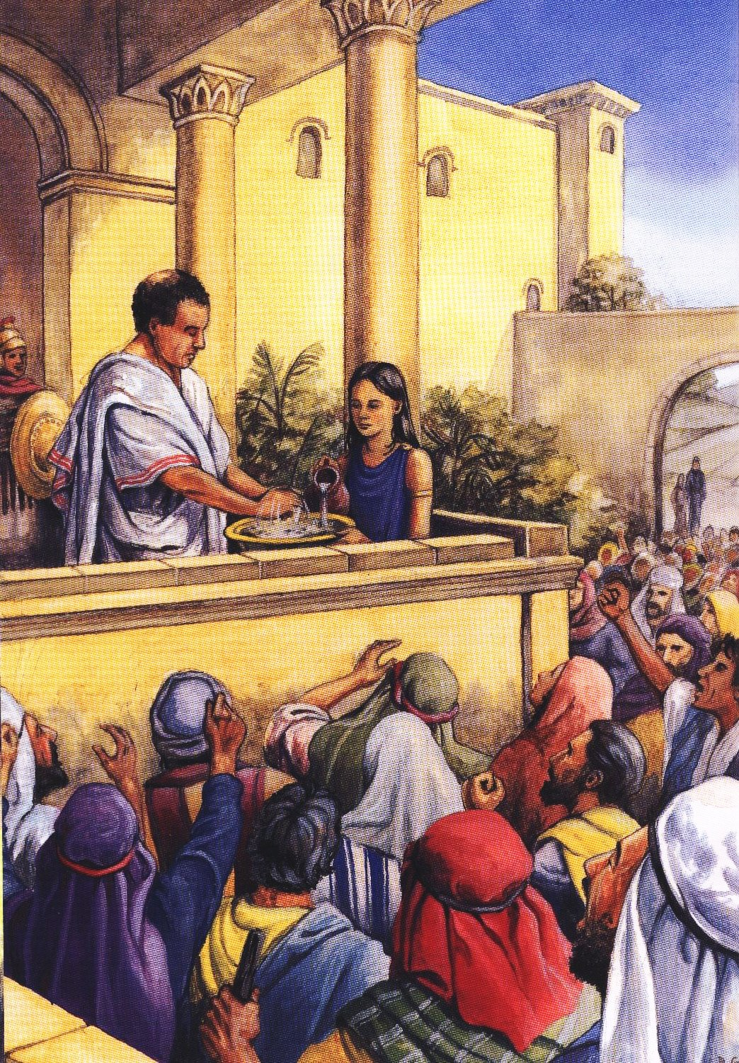
UPilatu wayekwazi ukuthi uJesu kenzanga lutho olubi, njalo wakutsho lokhu – kodwa wethuselwa ngabantu. Kodwa khangelani, ngubani lo okhulumayo khathesi? Ngumkakhe. Waba lephupho elesabekayo. Uthi: “Khulula uJesu”. Kodwa uPilatu kamlaleli. Uthatha inditshi yamanzi, ugeza izandla zakhe. Kungani? Utsho ukuthi kakusicala lami. Abesemthumela kuHerodi inkosi yamaJuda, kodwa uHerodi uyambuyisela futhi kuPilatu.
UPilatu ucabanga icebo elihle. EJerusalema entolongweni kulendoda eyesabekayo. Ithiwa nguBarabasi. Ulisela. Ungumbulali. UPilatu uthi ebantwini: “Lingakhululelwa indoda eyodwa. Lingathanda bani, uJesu kumbe uBarabasi?” Abantu basebememeza bathi: “Khulula uBarabasi”.

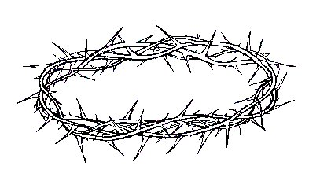
UJesu-ke utshaywa ngesiswepu okwesihluku, bayamtshaya. Bamgqokisa isembatho esiyibubende. Umqhele owenziwe ngameva acijileyo alesihluku ufakwa ekhanda lakhe. UPilatu-ke umletha phambi kwabantu bonke umemeza athi: “Khangela lindoda!”

Yeka uthando lukaJesu ukuthi wayevuma kangakanani ukuthi afe. Kamtshelanga yini uPilatu ukuthi aluba ubethanda ukuthi inkulungwane zezingilosi ezikhazimulayo ezilodumo zehle zivela ezulwini zizemkhulula. Kodwa hatshi! Hatshi khathesi. Kumele afe.

Kathathu uPilatu watsho ukuthi uJesu kenzanga lutho olubi, kodwa ekucineni wavuma kumele afe. Kumele athethelelwe.

Ngakho-ke ethwele isiphambano sakhe bamqhuba bamusa endaweni okuthiwa uKhakhayi ukuthi ayekufa.

Ungakufunda ngalokhu kuMatewu isahluko 27, amavesi 1 kusiya ku-31; uMarko isahluko 15, amavesi 1 kusiya ku-20; uLuka isahluko 23, amavesi 1 kusiya ku-25; uJohane isahluko 18, amavesi 28, kusiya kusahluko 19, ivesi ka-15.

Indlela Eya KuKhakhayi

Uba ungaya eJerusalema ungahamba wehle ngaso lesositalada uJesu owahamba esehla endleni yakhe esiya eKhakhayi. Yayingumcingo. Yayibizwa ngokuthi iVia Dolorosa. Lokhu kusitsho ukuthi INDLELA EDANISAYO YOSIZI; yayindlela edanisayo elosizi yeNkosi uJesu.

Kwakusekuseni kakhulu kodwa izitalada zaziminyene. UJesu kwakufanele athwale isiphambano sesigodo ayezabethelwa kuso. Kodwa wayediniwe kakhulu. Umhlane wakhe wawudatshuliwe usopha. Kwakunjalo ngekhanda lakhe. Lingakhohlwa ukuthi wayenguMuntu sibili njalo enguNkulunkulu olamandla wonke.

Njengoba udwendwe lwaqhubeka, ngesihluku uJesu eqhutshelwa endaweni lapho eyezabethelwa khona, kwamiwa okwesikhatshana. Kwakulendoda okuthiwa nguSimoni. Kwathiwa kayithwalele uJesu isiphambano. Kwakukhona-ke abesifazana abalutshwana ababesosizini. Yebo babengabalalo! Ngitsho lokukhala bekhangele uJesu ehamba esiyakufa. Kodwa uJesu wabatshela ukuthi bangamkhaleli kodwa bazikhalele bona.

Udwendwe lwadabula amasango omuzi. Lwaphumela ngaphandle komduli womuzi. Kakulentatshanyana ethiwa yiKhakhayi. UJesu bambethela lapho.

“Kunjalo ukufa kwesihluku akufayo,
Walengiswa njalo wabethelwa;
Lalezozandla ezilomusa ezenza okuhle kangaka,
Bazibethela esiphambanweni sesigodo.”

Amankazana labafana abanengi kabaqedisisi ukuthi kungani uJesu wafa. Kungani kulokunengi kangaka eBhayibhili ngesiphambano? Ngani okunengi kangaka ngoJesu esifa? Kuyini okuqakathekileyo? Kulani lokwenza ukuthi abantu bathethelelwe? Kungani ukuthi bekungebe lamunye ongaya ezulwini aluba uJesu engazanga abethelwe?

UNkulunkulu wathi bonke abenza okubi bazajeziswa. Sonke senzile okubi. Ngakho sonke sifanele ukujeziswa. Kodwa uJesu uthe angajeziswa yena esikhundleni sabantu bakhe, ngenxa yezono zabo, ukuze bona bangajeziswa.

Yikho wabethelwa. Kungenxa yalokho wafa.

“Wakwazi ukuthi abantu babekhohlakele njani;
Wakwazi ukuthi uNkulunkulu umele ajezise isono;
Ngakho ngenxa yesihe uJesu wathi
Uyakuthwala isijeziso esikhundleni sabo.”

Zonke izibusiso ezinhle lezomusa abantu bakaNkulunkulu abazemukelayo ziza ngoJesu ekubafeleni kwakhe.

Ungafunda ngalokhu kuMatewu isahluko 27, amavesi 31 kusiya ku-35; uMarko isahluko 15, amavesi 21 lo-22; uLuka isahluko 23, amavesi 26 kusiya ku-31.

Ukubethelwa

Kwakulihola lesificamunwemunye ekuseni lapho uJesu ebethelwa. Phezu kwekhanda lakhe kwakulebhakane: LO NGUJESU INKOSI YAMAJUDA. Okwamahola ayisithupha walenga, wopha, esifa phezu kwesiphambano.

Phakathi laphakathi kwemini yonke into yafiphala. Kwabamnyama njengaphakathi laphakathi kobusuku – lanxa kwakuyisikhathi sentwasa njalo kuphakathi kwemini lapho ilanga elikhanya khona kakhulu. Kwakungathi ilanga lifanele lizifihle nxa iNkosi yakho konke isifa.

Labo abazingelezeleyo bakloloda, abedlulayo, abapristi, amabutho; amabutho aze atshova amakhasi ukuthi ijazi likaJesu lizakuba ngelikabani. Omunye wamnika okunathwayo – kodwa kubaba kangakanani! Liviniga.

Khumbula ukuthi uJesu kazange enze ulutho olubi njalo kwakulula kangakanani ukuthi aphephe.

Okwalamahola ayisithupha uJesu wayethule. Wakhuluma nje kasikhombisa.

Wakhuluma kanye loJohane. Liyamkhumbula yini uJohane? Ngumfundi owayengumntwana kulabo bonke abafundi uJesu owayemthanda ngothando olukhulu. UJesu wakhangela ngomusa langothando unina uMariya owayelosizi, wathi uJohane kamkhangele.

Esenzela labo ababelesihluku kuye uJesu wakhuleka wathi, “Baba, bathethelele, kabakwazi abakwenzayo.”

Amasela amabili abethelwa ngesikhathi sinye laye, omunye lomunye kuhlangothi lwakhe. Ayengamadoda amabi ababefanele ukufa. Okokuqala bonke bamklolodela uJesu.

Kodwa khathesi, kuyini osekusenzakala? Omunye uyakhuluma. Lalela! “Thina sifanele ukufa, kodwa lindoda kayenzanga lutho olubi”. Isela leli lakwazi njani ukuthi uJesu kenzanga lutho olubi, ukuthi wayengelacala? Kodwa khathesi lelisela liyakhuleka kuJesu. Ubiza uJesu uthi NKOSI. Uyamcela ukuthi amkhumbule nxa esefika embusweni wakhe. Uyakwazi ukuthi uJesu uyiNkosi.

Isela elifayo lazifunda njani izinto zonke lezi? Ukuthi uJesu uyiNkosi? Ukuthi yena ulombuso? Ukuthi singakhuleka kuye? Lokuthi kulethemba emuntwini omubi osechithe impilo yakhe ezintweni zenkohliso? UMoya oNgcwele wamfundisa izinto lezi enhliziyweni yakhe.

Kodwa khathesi lalelani uJesu iNkosi. Amazwi amangalisayo alomusa angakanani yena awakhuluma khathesi. Utshela isela elifayo ukuthi ngalona lolusuku uzakuba laye ezulwini! Yikho okutshiwo yiBhayibhili nxa ikhuluma “ngesisa”.

Ekucineni iNkosi uJesu wamemeza wathi: “KUPHELILE”. Zonke inhlupheko zakhe lobuhlungu bakhe basebuphelile. Impilo yakhe emhlabeni yayisiphelile – kodwa uJesu wayesithini sibili? Umsebenzi wakhe omkhulu owokusindisa abantu bakhe khathesi wawusuphelele. Segobisa ikhanda lakhe ngobumnene wafa.

Kwahle kwaba khona ukuzamazama komhlaba okwesabekayo. Umhlaba wanyikinyeka, ngitsho lamadwala adabuka aba yizicucu. Lowo oweyesand'ukufa wayeyiNkosi yakho konke, amaqaqa lamahlathi lamadwala lezintaba. Khathesi-ke lomhlaba ngokwawo ufanele ukhulume!

Kube kanti izitha zikaJesu kufanele zibe lokujikijela kwazo kokucina, lebutho elilesihluku lagxumeka umkhonto ehlangothini lukaJesu. Kodwa elinye ibutho likhangela umzimba ongaselampilo lamemeza lathi: “Isibili, luMuntu ubeyiNdodana kaNkulunkulu.”

Ungafunda ngalokhu kuMatewu isahluko 27, amavesi 33 kusiya ku-56; uMarko isahluko 15, amavesi 23 kusiya ku-41; uLuka isahluko 23, amavesi 32 kusiya ku-49; uJohane isahluko 19, amavesi 16 kusiya ku-37.

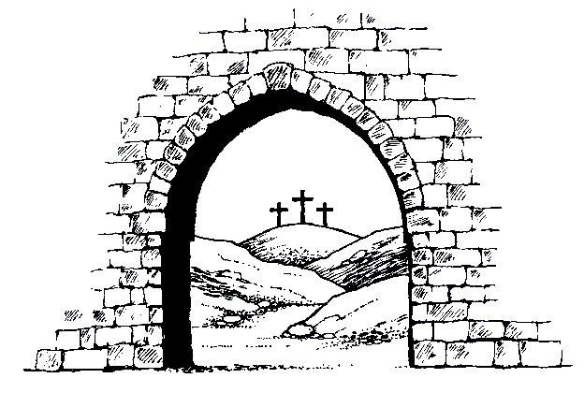
Umngcwabo

Kwasekuntambana. Izehlakalo ezesabekayo zosuku zasezedlule. Isabatha masinyane lizakuba selikhona.

Kodwa ngubani lo ohaluzela ezitaladeni zeJerusalema? Uhamba uya esigodlweni samaRoma lapho uPilatu ahlala khona. Kufanele abone uPilatu. Ubonakala angathi unothile kakhulu, indoda eqakathekileyo. NguJosefa owaziwa njengoJosefa weArimathiya.

Uyangena ngesibindi. UPilatu kuyammangalisa kangakanani! UJosefa ufunisisa kakhulu ulutho. Uyacela ukuthi angaphiwa isidumbu sikaJesu, ukuze singangcwatshelwe. UPilatu-ke uthi, “Yebo”.

Ngothando uJosefa uyahaluzela ebuyela eKhakhayi. Lalapho ubona enye indoda enothileyo leqakathekileyo isondela esiphambanweni. NguNikodima owake weza kuJesu ebusuku ngoba wayesesaba. Kodwa njengoJosefa kasesabi. NjengoJosefa angekuthwale ukukhumbula ukuthi isidumbu esingcwele seNkosi uJesu siyekelwe esiphambanweni – kumele azuze umngcwabo oqondileyo. Okweminyaka engamakhulu mandulo abaprofethi bakaNkulunkulu babetshilo ukuthi kwakuzakuba njalo.

Ngesisa laba ababili basethula isidumbu sikaJesu basithwala besisa esivandeni esasiseduze. Lapho okwakulengcwaba khona elalingelikaJosefa. Lalifanana lobhalu ligujwe edwaleni. Lapha babeka kuhle umzimba kaJesu ongeselampilo. Babengenze okwaneleyo. Amakha aligugu alingana impondo babebuye lawo ukugcoba isidumbu sakhe!

Ilitshe elikhulu lagiqelwa emlonyeni wengcwaba. Kwathi sekwedlule lokho ababusi bamaJuda besazi okwenzakeleyo baphawula ilitshe baletha abalindi bebutho, ukuthi bagcine umlindo – ukuze kungabi khona ozasusa isidumbu asebe.

Bangaphi oPetro loJakobe loJohane labanye khathesi? Bonke sebebalekile. Kodwa ngokuthula abanye balabo abesifazana abamthandayo uJesu ngothando olukhulu bayakhangela.

* * *

Lapho isidumbu sikaJesu salala emqandweni, engcwabeni elithuleyo, ephumula ngokuthula. Umsebenzi wakhe uwuqedile. Kodwa kwakungelakwenzeka ukuthi uJesu ahlale lapho. Ekuseni kakhulu ngosuku lwesithathu kwaba khona ukuzamazama komhlaba. Ingilosi engcwele yehla ivela ezulwini, yaligiqela khatshana ilitshe. UJesu waphuma engcwabeni. Uyaphila njalo! UnguMsindisi ovukileyo. Uyaphila kuze kube phakade. Wake wabethelwa, kodwa khathesi uyaphila ukuthi angabuyi afe njalo. UnguMsindisi olamandla wonke.

Ungafunda ngalokhu kuMatewu isahluko 27, amavesi 57 kusiya ku-66; uMarko isahluko 15, amavesi 42 kusiya ku-47; uLuka isahluko 23, amavesi ka-50 kusiya ku-56; uJohane isahluko 19, amavesi ka-38 kusiya ku-42. Izahluko ezilandelayo zikhuluma ukuthi uJesu wavuka njani kwabafileyo.

