UJohane uMbhabhathizi

Amaxuku abantu ayesiya enkangala. Akubabone betshiya imizi yabo. Abanye babesuka emzini omkhulu weJerusalema. Abanye njalo babevela kumizana emincinyane. Abanye kwakungabantu ababi abangelamusa. Abanye njalo bengabantu ababezicabanga ukuthi bangabalungileyo. Kwakulemihlobo yonke yabantu.

Kanti babesenzani? Kungani njalo babesiya enkangala? Inkangala yindawo engahlalimuntu. Kulutshwana okukhula lapho. Umhlabathi wakhona ulukhuni futhi ugcwele amatshe. Pho babefunani?

Babesiyabona indoda okwakuthiwa nguJohane. Sande ukumuthi ngu“Johane uMbhabhathizi”. Babefuna ukuyamlalela ekhuluma.

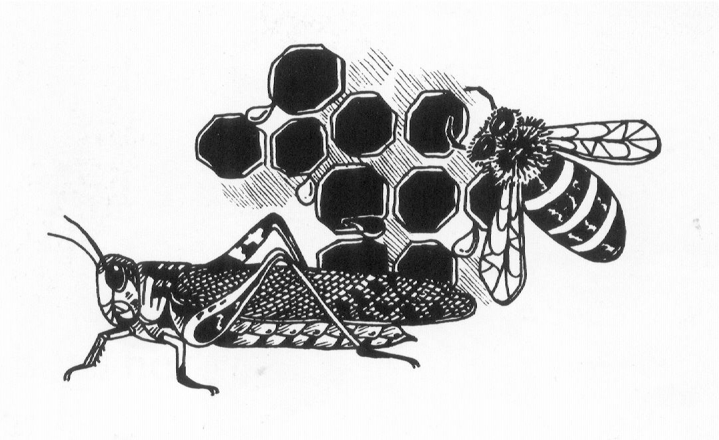
Angazi ukuthi kambe abantu abamangalanga yini mhla bebona uJohane okokuqala? Wayesemutsha sibili kodwa wayelenwele lendevu ezinde. Wayegqoka izigqoko ezingatshukekanga (zazenziwe ngoboya bamakamela), futhi ekhalweni lwakhe wayelebhanti lesikhumba. Wayehlala eyedwa phandle enkangala. Ukudla ayesenelisa ukukuthola kwakuzinyosi (ezazisenziwa zinyosi emadwaleni) lokuyizibungwana okuphaphayo okuthiwa zintethe (akugolayo).

Kodwa uJohane wayengumuntu olungileyo. Wayengumuntu kaNkulunkulu. Nxa etshumayela, abantu babelalela. Wayebatshela ukuthi bayizoni. Wayebatshela ukuthi uNkulunkulu ubazondele kwakumele baphenduke – babe lusizi ngezono zabo besebezitshiya. Sonke sifanele ukuphenduka. Sengathi singacela uNkulunkulu ukuthi asiphe uphenduko.

Nanzelela ukuthi uJohane wenzani! Umbone esusa lababantu ebasa emfuleni iJordani (owawugeleza khonapho eduzane) njalo ebacwilisa emanzini. Uyababhabhathiza. Kodwa hatshi bonke. Labo kuphela ababezisola kakhulu ngezono zabo.

Kwathi ngelinye ilanga iNkosi uJesu ngokwakhe weza ukuzabona uJohane. Laye wacela uJohane ukuthi ambhabhathize. Ekuqaleni uJohane wathi “Hatshi”, wayengafanele ukubhabhathiza uJesu, iNkosi yakhe loMfundisi. Futhi-ke kazange aqedisise ukuthi uJesu kungani wayefuna ukuthi abhabhathizwe; wayengayisiso isoni. Kodwa-ke uJohane wenza njengalokhu uJesu wayetshilo.

Kodwa khathesi kwenzakala izimanga bani! Kwathi lapho uJohane ephakamisa iNkosi eyikhupha emanzini, ijuba elihle lehla lahlala phezu kwekhanda layo. Kwakungesilo juba elejwayelekileyo. KwakunguMoya oNgcwele evela ezulwini esehla njengejuba. Futhi-ke kwezwakala ilizwi livela ezulwini – ilizwi likaNkulunkulu uYise. Lathi: “Lo yiNdodana yami ethandiweyo, engithokoza ngayo”.

Kuthe ngolunye usuku, uJohane etshumayela, iNkosi uJesu wafika njalo. UJohane wathaba kakhulu. Wakhangela uJesu wamemeza: “Khangela iWundlu likaNkulunkulu”. Ibizo elihle kangakanani leNkosi uJesu, “iWundlu likaNkulunkulu”. IWundlu – limnene, lithobekile njalo lihlanzekile, kodwa iWundlu leli ngolunye usuku lalizabulawa.

Abantu baqala ukusuka kuJohane sebesiyahamba loJesu. Kodwa uJohane wajabula kakhulu. Wayeyithanda iNkosi uJesu ngothando olukhulu.

Futhi-ke leNkosi uJesu yayimthanda uJohane ngothando olukhulu. Uyakwazi ukuthi yathini ngoJohane? Yathi kubo bonke abantu abake baphila, kakho owake wabamkhulu kuloJohane uMbhabhathizi.

Lokhu ungakubala kuMathewu isahluko 3; kuMarko isahluko 1 amavesi 1 kusiya ku-11; lakuLuka isahluko 3 amavesi 1 kusiya ku-22; lakuJohane isahluko 1 amavesi 29 kusiya ku-37.

Cela uNkulunkulu ukuthi akuphe umusa ukuthi uphenduke ukholwe eNkosini uJesu. Yilabo kuphela abaphendukayo bakholwe abaxolelwayo.

Umfazi Emthonjeni

Ngelinye ilanga uJesu wayedinwe kakhulukazi. Ubukwazi yini ukuthi uJesu ngezinye izikhathi wayedinwa njengalokhu lathi sidinwa? Phela wayenguMuntu isibili lanxa nje wayenguNkulunkulu uSomandla.

INkosi uJesu yayiphakathi kohambo olude. Kwakuphakathi kwemini lapho ilanga liyabe litshisa khona bhe. Phezu kokudinwa yayomile. Angazi ukuthi sewake woma isibili? Ngakho yahlala phansi ukuthi iphumule emthonjeni. Kwakusemthonjeni odumileyo othiwa “Umthombo kaJakobe”.

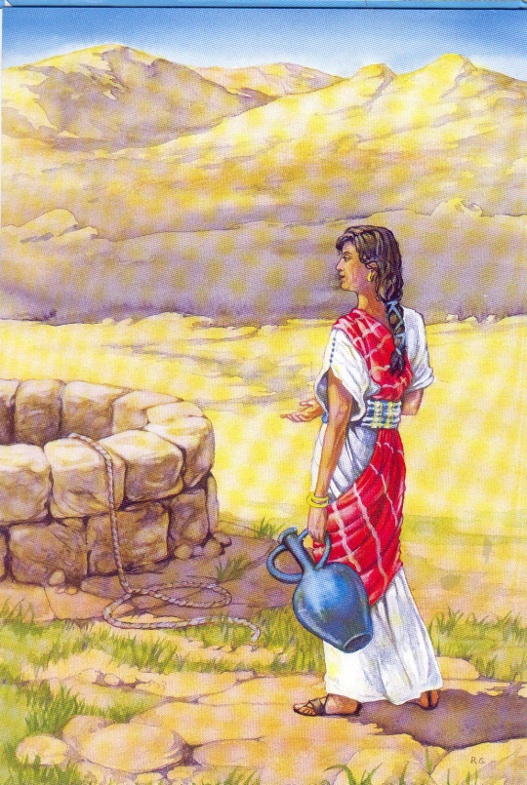
Wathi esahlezi lapho kweza umfazi othile emthonjeni. Wayethwele inkonxa ukuze akhe amanzi. Mhlawumbe wayeyithwele ekhanda.

Umfazi lo wayengumfazi omubi. Lanxa yena wayengakunanzeleli, uJesu wayemazi ukuthi ungumfazi omubi njani, futhi esazi lalezozenzo zakhe ezimbi ayezenza. INkosi uJesu wazi konke ngathi munye ngamunye.

UJesu wacela lo umfazi ukuthi amnathise amanzi. Wamangala lumama, kodwa waqala ukukhuluma laye.

Masinyane nje wananzelela lumfazi ukuthi iNkosi uJesu wayelomehluko othile. Waqala ukucabanga ukuthi iNkosi uJesu kumele abe ngumprofethi. Kambe kwakungenzeka njani ukuthi uJesu azi konke ngaye? Babengakaze babonane.

Emva kwalokho uJesu iNkosi waqala ukukhuluma ngalokho akubiza ngokuthi “ngamanzi aphilayo”. Kambe ngabe waye esitshoni? Wayengelamgqomo loba inkezo yokukha amanzi, futhi lomthombo lo wawutshona kakhulu. Wethuka kakhulu, lumama.

Wayesitshoni uJesu? UJesu eqinisweni waye sitsho lokhu. Izibusiso zikaNkulunkulu zifanana lamanzi athandekayo aqandelelayo kulabo abomileyo. Sengathi uMoya oNgcwele angasifundisa ukuthi “amanzi aphilayo” ayini size siwomele.

Kwathi lapha umfazi lo esebonile ukuthi uJesu wayesazi konke ngendlela zakhe ezimbi, lokuthi wayengumprofethi, wasecabanga ukuthi akhulume laye ngezinto zonke abuze imibuzo ngokunengi-nengi. Mhlawumbe wayezama ukuthi abalekele isihloko abephezu kwaso.

Ekucineni waphetha ngokuthi: “Nxa uMesiya iNdodana kaNkulunkulu esebuyile kulumhlaba, uzakwenelisa ukusipha impendulo zemibuzo yonke le”.

Wamangala okunjani lumama! UJesu wathi: “Nginguye”.

Isibili iNkosi yazibonakalisa kulo umyangakazi kamama olesono ngendlela ecacileyo kakhulu kulakubanye bonke iNkosi eyahlangana labo. Kambe wezwa njani lo umama?

UJesu wamthanda, uyabona. Wamthola. Wamtshengisa lokho lo umama ayengelakho. Wamxolela. Wayengaseyikubuye aphile impilo ekhohlakeleyo futhi.

Uyakwazi okwenziwa ngumama lo? Watshela ubani lobani ngalo uMuntu omangalisayo ayesehlangane laye. Okunye akwenzayo uyakwazi yini? Wahle wakhohlwa imbiza yakhe yamanzi. Wahle wayitshiya emthonjeni. Wayesezuze lokho okungcono.

Ungabala indaba le kuJohane isahluko 4 amavesi 1 kusiya ku-42.

Cela iNkosi uJesu ukuthi ikufundise ukuthi “amanzi aphilayo” ayini.
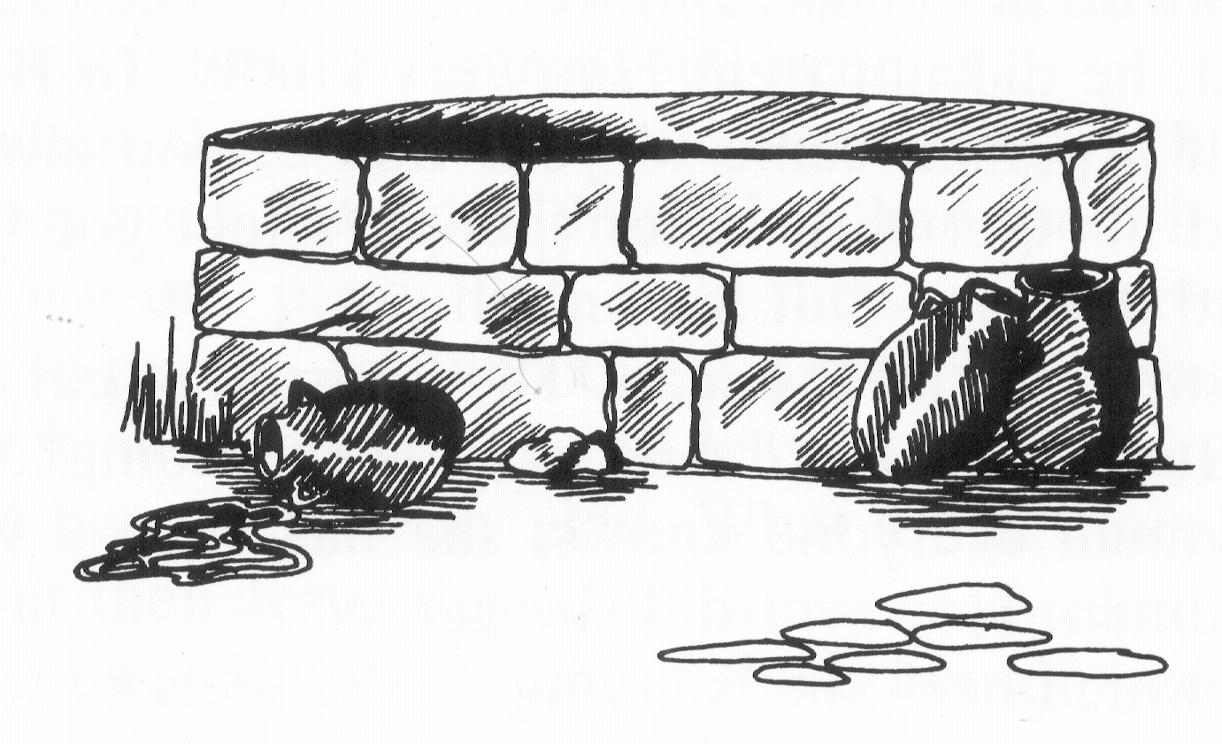
Umfazi Endlini KaSimoni

Ngesikhathi uJesu eselapha emhlabeni, kukhona abanye abantu ababengamthandi. Babeyizitha zakhe. Babebizwa ngokuthi ngabaFarisi. Babecabanga ukuthi balunge kakhulu – kodwa iqiniso yikuthi babengenjalo. Babengamthandi uJesu ngenxa yokuthi wayebatshela lezozinto ezimbi ababezenza.

Kodwa ngolunye usuku omunye walabobaFarisi wanxusa uJesu ukuthi eze adle laye ntambama. Ibizo lakhe lalinguSimoni.

Kuyamangalisa ukuthi kungani wanxusela uJesu endlini yakhe. Asikwazi sibili. Kodwa siyazi ukuthi lapho uJesu esefike endlini yakhe, kazange amphathe ngomusa. Ngensuku zeBhayibhili, nxa umuntu ethekele emzini wakho, sonke isikhathi kwakumele umgezise inyawo (inyawo zazisuke zibe lothuli, zitshise) – kodwa uSimoni kamgezisanga uJesu.

Lanxa kunjalo, kwaqala ukudliwa. Baqala ukudla lokuxoxa. Kodwa ngubani lo? Futhi wenzani lo owesifazana? Ngumfazi owaziwa ngabantu bonke; ngumfazi obephila impilo embi. Ungene njani lapha?

Akumkhangele! Uyakhala – uzwa elusizi kakhulu ngezinto zonke ezimbi abezenza – futhi ukhala kakhulu inyembezi zakhe zize ziwele enyaweni zikaJesu. Khathesi usekhothama ahlikihle inyawo zikaJesu ngenwele zakhe ezinde. Usezanga izinyawo. Uyithanda kakhulu kanganani iNkosi uJesu! Khathesi-ke usethela inyawo zeNkosi ngamafutha anukelelayo amahle ukuze aziqandise.

USimoni wakhangela konke lokho ngokumangala. Kwakungamthokozisi ngitsho. Waqala futhi ukucabanga imicabango emibi. Wacabanga ethi: “Bonke abantu bathi uJesu ngumprofethi. Kasuye ngitsho – ngoba ngabe ebenguye ngabe wazile ukuti lumfazi ngubani. Uyisoni lumfazi.”

Manje uJesu wayesazi konke uSimoni ayekucabanga. Ubukwazi yini ukuthi zonke izinto ozicabangayo wena yena uyazazi? Kakho omunye okwaziyo wena okucabangayo, kodwa uJesu uyakwazi.

Kusenjalo, uJesu wasexoxa okuyindatshana. Wathi kwake kwaba lendoda eyayilemali enengi. Waseboleka enye yale imali abantu ababili abatshiyeneyo, futhi kwakumele bayibuyisele kuye. Komunye webolekisa amatshumi amahlanu emali; kwathi komunye wabolekisa amatshumi amahlanu aphindwe katshumi – amakhulu amahlanu emali.

Kwathi sekufika isikhathi sokuthi babuyisele imali lezi kumninizo, behluleka. Basebeyisebenzise yonke bayiqeda. Babengasela ngitsho lesenti yayo. Manje kwasekumele baye ejele, akunjalo yini? Kodwa umninimali wayeyindoda elesisa kakhulu-khulu. Wathi: “Ngizalixolela”. Kufanele ukuthi laba ababili bathokoza kakhulu. Indaba emnandi kangakanani!

Kodwa emva kwale indaba uJesu waphendukela kuSimoni. Wasembuza umbuzo ethi: “Simoni, phakathi kwababili laba, nguwuphi obona wathanda indoda eyabaxolelayo kakhulu?”

Lumbuzo wawulula kakhulu. Kusobala nje ukuthi yile indoda exolelwe ukubhadala amakhulu amahlanu emali eyayiwabolekile. USimoni waphendula lokhu ngokuphangisa.

Kodwa kungani uJesu waxoxa indatshana le? USimoni waphanga wakwazi.

UJesu watshibilikela kuye wathi: “Simoni, awugezisanga izinyawo zami. Umama lo ugezise inyawo zami ngezinyembezi, wazesula ngezinwele zakhe ezinde. Awunganganga. Lo umama wange izinyawo zami. Awugcobanga ikhanda lami ngamafutha. Lo umama ugcobe izinyawo zami. Yikho nje ngixoxe indatshana le. Umama lo uxolelwe izono ezinengi-nengi – yikho nje engithanda kakhulukazi.”

NguJesu kuphela ongaxolela izono. Wasesithi kowesifazana: “Izono zakho zixolelwe”. Kambe njabulo bani abalayo umama lo! Wahamba esuka lapho inhliziyo yakhe igcwele ukuthula – engolandela iNkosi uJesu ngothando.

Ungabala indatshana le kuLuka isahluko 7 amavesi 36 kusiya ku-50.

Lathi futhi sidinga ukuthethelelwa. Futhi kakho ongasithethelela ngaphandle kweNkosi uJesu. Kulelizwi elimnandi elihle elithi: “Uba sivuma izono zethu, uthembekile futhi ulungile ukusithethelela izono zethu, njalo asihlambulule kukho konke ukungalungi.”

Umbhali

Ngolunye usuku indoda eyayibonakala njengomuntu oqakathekileyo yeza kuJesu. Yayithiwa ngumbhali. Inengi lababhali babengamthandi uJesu. Kodwa lo wakhuluma kuhle kakhulu kuJesu. Yathi yona yayifuna ukuthi ihlale iloJesu ngesikhathi sonke. Yathembisa ukuthi yayingayikusuka kuJesu loba kutheni.

Kufanele sicabange ukuthi uJesu wajabula kakhulu ukuthi abe lalo umuntu oqakathekileyo ukuthi amsebenzele – akunjalo yini? Kodwa uJesu kathokozanga ngaye. Wayesazi mhlophe ukuthi lindoda yayingumuntu onjani. Wayesazi futhi ukuthi lumuntu wayezatshetsha adinwe ukulandela uJesu. Phela uJesu wazi konke ngathi. Uyakwazi lokhu kanye esiyikho. Aze azi kanye lalokho esiyabe sikucabanga – ngoba phela unguNkulunkulu.

UJesu wasexoxela umbhali lo indatshana. Uyakubone okwenziwa zinyoni ezincinyane nxa usuku seluphela? Ziphephela kuzidleke zazo ezikhudumalayo, kuthi lapho zigcinakale kuhle ebunandini ubusuku bonke. Sengitsho lamakhanka! Uyake ulibone ikhanka yini? Zinyamazana ezinhle ezilemisila emide eloboya; kodwa zilesihluku kakhulu. Lanxa kunjalo, kodwa lawo alendawo yawo ekhudumalayo agcinakala khona kamnandi ebusuku – imilindi emhlabathini.
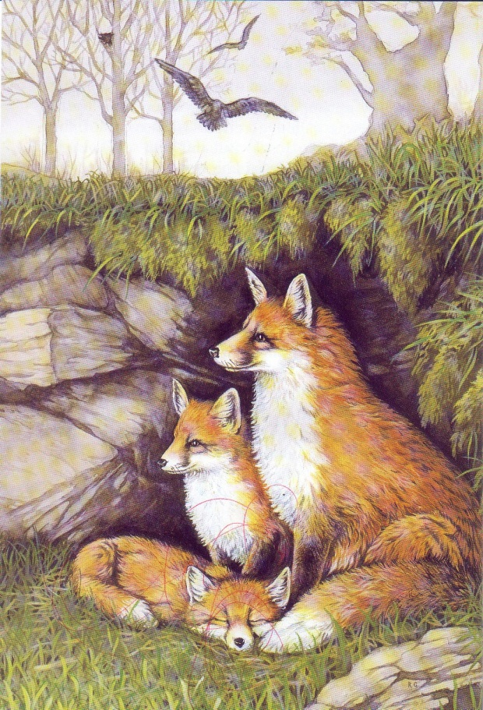
UJesu wasesithi: “Angilawo umuzi ongowami!” Akucabange ngalokhu! INkosi uJesu wenza izinto zonke, kodwa wayengalawo umuzi ongowakhe. Kwezinye izikhathi wayeqeda ubusuku bonke ephandle emaqaqeni aqandayo lezintaba.

UJesu wayesitsho lokhu: Nxa ungilandela, akuyikuba lula njengokucabangayo wena. Asikho ukuthi kuzakuba yikuhamba kwakho ukhangela ngisenza izimanga kuphela. Akuyikuba yikubona amaxuku abantu engilandela kuphela. Kuzakuba nzima. Labo ababelandela uJesu eselapha emhlabeni bahlangana losizi olunengi.

Kambe uyazi ukuthi umbhali kazange abe esakhuluma ilizwi lelilodwa ?

Waswela angakutsho. Asibuyi futhi sizwe lutho mayalena laye. Intengo yokulandela uJesu yayiphezulu kakhulu kuye.

Uyazi ukuthi iNkosi uJesu ngesinye isikhathi yathi: “Nxa umuntu ezangilandela, kazidele, athathe isiphambano sakhe, angilandele”. Sengathi singaba ngabalandeli bakaJesu beqiniso.

Indatshana le ungayayibala kuMatewu isahluko 8, amavesi 19 kusiya ku-20, lakuLukaisahluko 9 amavesi 57 lo 58.

Nanku umkhuleko omuhle omfitshane:

“Njengalokhu izinyoni zidinga indawo yazo yokuhlala,lezinto zonke ezidiniweyo zidinga indawo yokuphumula, sengathi lathi singakudinga njalo-nje Nkosi Jesu, ekupheleni kwalolusuku, lensuku zonke. Ameni.”

Amalephero Alitshumi

Lababantu uJesu ahlangana labo ngabangejayelekanga! Balitshumi sebebonke. Bakhanya becakile, njalo begula. Izikhumba zemizimba yabo zimahwalahwala njalo zingathi zingcolile. Leminwe yabo isiqala ukukhithika. Yebo, ngabalobulephero. Kwakuyinto eyesabekayo kangakanani ukuba ngumlephero!

Kabavunyelwa ukusondela kuloba ngubani. Kodwa zwana umsindo abawenzayo. Kuyini lokhu abakutshoyo?

“Nkosi, woba lesihawu kithi.”

Babesazi ukuthi uJesu wayelakho ukubenza babengcono – uba kuphela ethanda. Yikho nje bekhalela isihawu.

UJesu wabatshela ukuthi benze into emangalisayo. Wathi kabaye kumpristi, baziveze kuye. Manje lokho kwakusenziwa ngumuntu owayesenziwe waba ngcono. Kodwa la amalephero ayelokhu egcwele ubulephero.

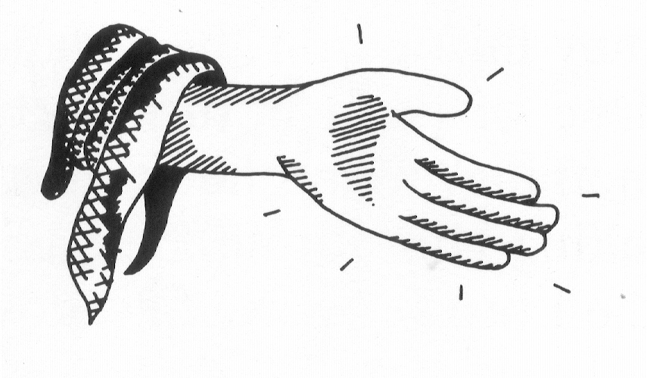
Kungasenani, benza njengokutshelwa kwabo. Besahamba, bananzelela munye ngamunye ukuthi basebengcono. Bajabula kangakanani! Ngeqiniso yiNkosi uJesu eyabenza basila; izikhumba zemizimba yabo zasezifanana lezikhumba zemizimba yabantu bonke nje.

Ngokuthokoza bahaluzela besiya phambili. Kodwa kuyini lokhu okwenzakalayo? Oyedwa wabo nango ephenduka. Angabe ekhohlwe olunye ulutho yini? Kuzwakala ehlabela izindumiso kuNkulunkulu embonga ngalokho uNkulunkulu akwenzileyo konke.

Ekufikeni kwakhe kuJesu wawa phansi daca ezinyaweni zakhe. Uthando olunganani olusenhliziyweni yakhe njalo wamkhonza okunganani uJesu iNkosi. Wayengelamazwi okumbonga okwaneleyo ngomusa wakhe.

Kuyamangalisa! Lo owakhumbula ukubonga wayevele engasuye omunye wabantu bakaNkulunkulu, amaJuda. Waye ngumSamariya – ongathandwa muntu.

UJesu wathokoza kakhulukazi. Uhlala ejabula njalonje nxa simbonga ngenxa yomusa wakhe. Kodwa wabuza umbuzo ethi: “Bangaphi abanye abayisificamunwemunye?” Kwakudanisa ukuthi babengabongi. Kodwa kwathi engakamtsheli ukuthi ahambe, iNkosi uJesu yakhuluma amazwi omusa kulowo owayephendukile.

Sonke sidinga ukwelatshwa – ngoba sonile kuNkulunkulu njalo sifanana lamalephero phambi kwakhe. Kodwa nxa iNkosi uJesu isithe yasihlambulula ngegazi layo, asibongeni.

Ungafunda indatshana le kuLuka isahluko 17, amavesi 11 kusiya ku-19.

Umkhuleko omuhle: “Ngigeze ezonweni zami”.

UZakhewu

Kwake kwaba khona indoda encinyane kakhulu okwakuthiwa nguZakhewu. Yayilemali enengi, kodwa okudanisayo yikuthi yayingasumuntu olungileyo. Yayiyisihwaba kakhulu. Yayingelamusa.

Kodwa ngolunye usuku yezwa kuthiwa uJesu wayezakwethekelela idolobho eyayihlala kulo, iJeriko. Ngakho yafisa ukumbona. Mhlawumbe yayisizwe ngazo zonke izinto ezimangalisayo uJesu ayesezenzile. Kodwa isizatho ngokwaso sokuthi kungani yafuna ukumbona asisazi.

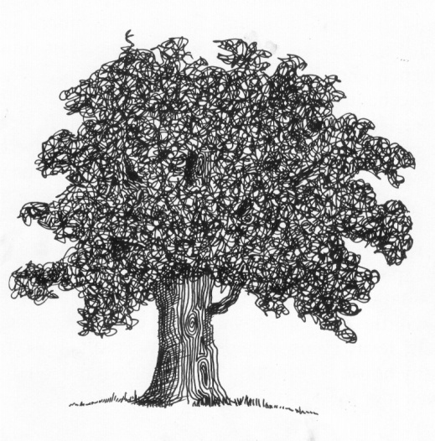
Kungasenani, yahamba. kodwa kwakulamaxuku abantu njalo uZakhewu wayemncinyane ngangokuba wayengenelisi ukubona phezu kwamakhanda abo. (Abanye benu lina abancinyane liyakwazi lokhu ukuthi kunjani – selake laba phakathi kwabantu abanengi, njalo libancinyane kakhulu, lingebone lutho.)

Kodwa licabanga ukuthi uZakhewu omncinyane wenzani? Wakhwela esihlahleni wazihlalela kuhle phakathi kwengatsha zaso. Kwakulicebo elihle, angitsho nje? Le indoda encinyane yayingasoze yadela masinyane. Kodwa kumele ukuthi abantu bamangala bembona ehlezi phezu kwesihlahla – akunjalo yini?

Ekucineni isikhathi esasilindelwe nguZakhewu safika. Okokuqala elapho wayibona iNkosi uJesu. Kodwa khangela ukuthi kwenzakalani? Kulomuntu obiza ibizo lakhe: “Zakhewu”. NguJesu ngokwakhe. Kwamethusa kangakanani lokhu. UJesu walazi njani ibizo lakhe?

Watshelwa nguJesu ukuthi aphange ehle esihlahleni. Ufuna ukuza endlini kaZakhewu.

Ngakho ngokuphangisa wehla uZakhewu esihlahleni, wasethatha uJesu emusa emzini wakhe.

Kodwa abantu babengakuzwisisi lokhu. Baqala ukungunguna bathi: “Kanti kungani ehambe loZakhewu? Kakwazi yini ukuthi ungumuntu omncinyane okhohlakeleyo?”

Kodwa uJesu wayekwazi kuhle. Wayeqonde ukuthi aguqule impilo yendoda le encinyane. Usakhumbula nje? UJesu wathi: “Angizanga ukubiza abalungileyo, kodwa izoni zize ekuphendukeni.”

UZakhewu waqala ukunanzelela ukuthi ungumuntu okhohlakeleyo kangakanani. Wazisola kakhulu. Njalo wayeqinisile ngakho – futhi wayefuna enze kubonakele lokhu. Wathi, “Nkosi, ngizanikela ingxenye yempahla zami kubayanga.” (Wayesazi ukuthi uJesu uyiNkosi.) Bonke labo ayebaphathe kubi wayesefuna ukuthi abancede. Labo ayebathathele imali wayesefuna ukubapha isiphindwe kane. Babezathaba njani!

Kwasekwenzakele inguquko enjani! UZakhewu useyindoda eguquke kangakanani! Singakuchasisa njani? UJesu ngokwakhe wathi, “Lamuhla usindiso luzile endlini yakho”. UJesu wayesemsindisile – njalo nxa esindisa kungokwa phakade.

Uyakwazi ukuthi kungani ethiwa nguJesu (“UMSINDISI”)? Ngoba “uzasindisa abantu bakhe ezonweni zabo”.

Indatshana le ungayifunda kuLuka isahluko 19, amavesi 1 kusiya ku-10.

Sengathi uMoya oNgcwele angakufundisa ukuthi uswela ukusindiswa ezonweni zakho. Lo ngumkhuleko omncinyane omuhle: “NKOSI, NGISINDISE ”.

Abantwana BeJerusalema

Abanye babantu uJesu ahlangana labo ngabantwana. Le indatshana imayelana labantwana beJerusalema.

Ekupheleni kwempilo yayo, iNkosi uJesu yaya eJerusalema igade ubabhemi. Yayilanda ukuyakufa esiphambanweni. Amaxuku abantu aphosela izigqoko zawo emgwaqweni (ukuyenzela isigcabha). Abanye baquma ingatsha zezihlahla bazizunguza. Abantu bamemeza besithi, “Hosana! Hosana!”

UJesu wahamba eqonde ethempelini eJerusalema. Lalinjengendlu enkulu yokukhonzela. Laliyindlu kaNkulunkulu. Kodwa phakathi kwakugcwele inhlobonhlobo zabantu bethengisa izinto. UJesu wazonda. Sande ukucabanga ngoJesu “obuthakathaka, omnene, othobekileyo” (kakunjalo yini?); kodwa kasingakhohlwa ukuthi uJesu uyasizonda isono. Kodwa akukhangele ubone akwenzayo! Ngokuphangisa waphosela phansi amatafula alabo ababethengisa izinto zabo, wagenqula izihlalo zabo, wabaxotshela phandle.

Emva kwalokho wasilisa abagulayo ngomusa omkhulu. Babekhona abayiziphofu, wabenza babona. Kwakulabayiziqhuli, wasebenza bahamba kuhle.

Kodwa khangela khathesi! Sekulabantwana lapho. UJesu wajabula ukubabona. Bamemeza besithi “Hosana” kuye. Abantwana abancinyane eJerusalema babefundiswe ukumemeza besithi “Hosana” kuNkulunkulu – kodwa ngubani owayesebafundise ukuthi bamemezele besithi “Hosana” kuJesu? Bambiza bemuthi “iNdodana kaDavida” - lowo owayezakuza, iNdodana ethandiweyo kaNkulunkulu.
Kwathi lapho uJesu egade ubabhemi engena eJerusalema, sitshelwa ukuthi bonke abantu babebuza lo umbuzo othi, “Ngubani lo?” Kodwa lababantwana abasethempelini babeyazi impendulo. Babesazi ukuthi uJesu ungubani. Babesazi ukuthi uyiNdodana kaNkulunkulu. Bamkhonza. Bamemeza besithi “Hosana!”

Uyamazi uJesu ukuthi ungubani? Ungawuphendula yini umbuzo owawubuzwa ngabantu bonke?

Kodwa nanku okudanisayo! Abapristi lababhali bazonda. Babengayithandi iNkosi uJesu njalo babengathandi ukuzwa lababantwanyana bememeza besithi “Hosana” kuye.

Baqala-ke ukusola. Baya kuJesu bamtshela ukuthi abathulise. Kodwa kakwenzanga. Wathi uNkulunkulu wayethembisile ukuthi abancinyane, ngitsho lezingane uqobo, zizamdumisa. Wabuye wathi nguNkulunkulu owayebafundisile.

Kakho phakathi kwethu omncinyane kakhulu okokuthi angeke afundiswe nguNkulunkulu. Kuyamangalisa kakhulu ukuthi abanye balabobantu uJesu ahlangana labo kwakungabantwanyana.

Indatshana le ungayifunda kuMathewu isahluko 21 amavesi 1 kusiya ku-16. Khangela njalo Isihlabelelo 8.

Khuleka kuJesu ukuthi akutshengise ukuthi wena uyini lokuthi yena ungubani.

UMariya Magadalena

Kulomfazi othile owayethanda iNkosi uJesu ngokukhethekileyo. Ibizo lakhe kwakunguMariya Magadalena. Wayeke waba ngumfazi okhohlakaleyo, kodwa uJesu wayesemxolele. Yikho wayemthanda kangaka. Wayetshiye imisebenzi yakhe emidala emibi, khathesi usethanda ukuba loJesu.

Lonke selizwile ukuthi uJesu wafa njani esiphambanweni, wasengcwatshwa engcwabeni.

Kodwa, ngubani lo osemi eceleni kwengcwaba, ekhala? NguMariya Magadalena. Ukhala kabuhlungu. Udane kangaka ngoba iNkosi loMbusi wakhe, uJesu, usefe ukufa okulesihluku esingaka.

Kodwa masinyane nje usezabona isimanga esikhulu sempilo yakhe yonke. Lanxa yena engakwazi, uJesu kasengofileyo. Uyaphila. Aluba nje uMariya ebekwazi lokhu.

Kodwa nanguya lokhu ekhala. Usekhangela phakathi kwengcwaba. Ubonani? Ingilosi ezimbili ezingcwele zigqoke okumhlophe – futhi zikhuluma laye. Ziyambuza ukuthi kanti ukhalelani. Kambe wena, lami asingethokoze yini nxa izingilosi ezimbili zingeza zikhulume lathi? Kodwa uMariya wayengathokozanga. Wayefuna uJesu kuphela.

Ingcwaba leli lalisesivandeni. Njalo iNkosi uJesu yayimi kulesisivande, ikhangele uMariya. Yayimthanda ngothando olukhulu kangakanani!

Ngokuphangisa uMariya watshibilika - khonapho wahle wabona uJesu. Kodwa kazange amnanzelele. Mhlawumbe kwakungenxa yokuthi amehlo akhe ayegcwele inyembezi. Kumbe mhlawumbe waye ngasenjengakuqala. Wayecabanga ukuthi nje yindoda eyayigcina izihlahla lamaluba esivandeni – umgcinisivande.

Umgcinisivande ngomusa wambuza ukuthi wayefunani lapho njalo wayekhalelani.

“Hawu” watsho uMariya, “umsusile yini? Ngicela ungitshele ukuthi umbeke ngaphi.” Wayengazi ukuthi ukhuluma loJesu.

Khonokho, engalindele, wezwa ilizwi libiza ibizo lakhe. Lalisithi, “Mariya”. Lalililizwi likaJesu. Kodwa kwakungenzeka njani? Owayelokhu ekhuluma kwakungumgcinisivande.

Ngokuphangisa wakwazi. Leyo ndoda yayingasumgcinisivande; kwakuyiNkosi uJesu. Hawu, lathandeka kakhulu njani lelolizwi kuye! Wayengakaze ezwe ulutho oluthandeka kangaka. Kutsho ukuthi uJesu uyaphila.

Khonokho waphenduka wasesithi kuye, “Raboni – Mfundisi wami othandeka kakhulu”.

Kuyamangalisa njani ukuthi phakathi kwabo bonke abangane labalandeli bakaJesu, waqala ukuza kuMariya Magadalena ngemva kokuvuka kwakhe kwabafileyo! Wathokoza okwedlula omama bonke emhlabeni. Akusekho zinyembezi khathesi – uselentokozo.

Ucabanga ukuthi wenzani? Wahaluzela ngokuphangisa wayatshela abafundi bakaJesu. Wathi, “Ngiyibonile iNkosi”.

Yebo, uJesu usaphila lalamuhla. Sengathi lathi, njengoMariya Magadalena, besingalazi ilizwi lakhe. Sengathi futhi besingamthanda njengalokhu yena wamthanda.

Ungazibalela indatshana le kuJohane isahluko 20 amavesi 11 kusiya ku-18.

Nsuku zonke ekuseni ngosuku lweNkosi, amaKrestu akudala ayejwayele ukukhulumisana ngokuthi, “INkosi ivukile ngeqiniso”.

